**Test Planning Worksheet**

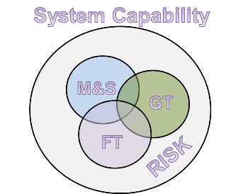**What is the objective of this test?**

**Where can you test for this objective? [e.g., lab, M&S, ground test, flight test]**

**Is the response of the experiment deterministic (same output for same input conditions) or random?**

**Can you execute this test sequentially (e.g., in multiple phases)?**

**Are there interaction effects between factors of particular interest? Are there other model terms (e.g. quadratic effects) of particular interest?**

|  |  |
| --- | --- |
| **Resources And Design Information** | |
| Anticipated Total Run Budget |  |
| Confidence Goal [80-99% common] |  |
| Power Goal [minimum 80% common] |  |
| Estimated value of system noise ( $σ)$ |  |
| Desired value of $δ$ (Signal in response to detect) |  |
| Signal-to-Noise Ratio (SNR) = $δ/σ$ |  |

Using the STAT Planning Worksheet and a STAT Expert, describe the planned test strategy:

|  |
| --- |
|  |